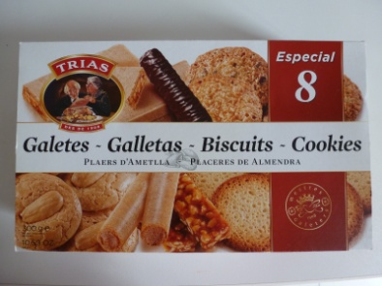
VISITA A LA FÀBRICA TRIAS
- -On està situada la fàbrica Trias ? ( Indica el municipi i la comarca)
_________________________________________________________________________________________
- –Quina activitat econòmica es porta a terme a Trias? I a quin sector econòmic pertany aquesta activitat?
_________________________________________________________________________________________
- -Qui va fundar l’empresa? I quan?
_________________________________________________________________________________________
- -Com era l’empresa als primers anys d’activitat?
_________________________________________________________________________________________
_________________________________________________________________________________________
_________________________________________________________________________________________
_________________________________________________________________________________________
________________________________________________________________________________________
- Hi ha hagut canvis en les instal·lacions de l’empresa al llarg del segle XX? Quins?
_________________________________________________________________________________________
_________________________________________________________________________________________
_________________________________________________________________________________________
_________________________________________________________________________________________

- Hi ha hagut canvis en els productes que ofereix l’empresa des que va començar fins ara? Quins?
_________________________________________________________________________________________
_________________________________________________________________________________________
_________________________________________________________________________________________
_________________________________________________________________________________________
_____________________________________________________________________________________

- Aquesta empresa porta en funcionament més de 100 anys, quins creus que són els motius del seu èxit?
_________________________________________________________________________________________
_________________________________________________________________________________________
_________________________________________________________________________________________
_________________________________________________________________________________________
_________________________________________________________________________________________
_________________________________________________________________________________________
_________________________________________________________________________________________
- Si tu haguessis de crear una empresa digues què copiaries de l’empresa TRIAS i per què ho copiaries?
_________________________________________________________________________________________
_________________________________________________________________________________________
_________________________________________________________________________________________
_________________________________________________________________________________________
_________________________________________________________________________________________
_________________________________________________________________________________________
_________________________________________________________________________________________
_________________________________________________________________________________________
_________________________________________________________________________________________
- Què has trobat més interessant:
_________________________________________________________________________________________
_________________________________________________________________________________________
_________________________________________________________________________________________
_________________________________________________________________________________________
_________________________________________________________________________________________

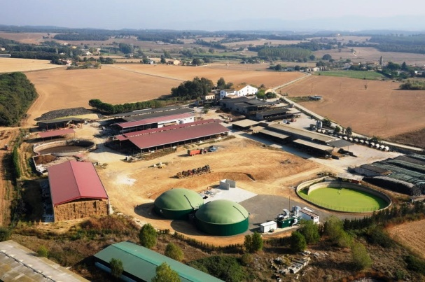 VISITA A MAS BES
- -On està situada la granja Mas Bes ? ( Indica el municipi i la comarca)
_________________________________________________________________________________________
- –A quina activitat es dediquen a Mas Bes? I a quin sector econòmic pertany aquesta activitat?

________________________________________________________________________________________

________________________________________________________________________________________
- -Qui va iniciar l’activitat? I quan?
_________________________________________________________________________________________
- -Com era la granja als primers anys d’activitat?
_________________________________________________________________________________________
_________________________________________________________________________________________
_________________________________________________________________________________________
_________________________________________________________________________________________
________________________________________________________________________________________
- Hi ha hagut canvis en les instal·lacions de la granja al llarg dels anys ? Quins?
_________________________________________________________________________________________
_________________________________________________________________________________________
_________________________________________________________________________________________
_________________________________________________________________________________________

- Hi ha hagut canvis en els productes que ofereix l’empresa des que va començar fins ara? Quins?
_________________________________________________________________________________________
_________________________________________________________________________________________
_________________________________________________________________________________________
_________________________________________________________________________________________
_________________________________________________________________________________________
- Aquesta empresa porta en funcionament molts anys, quins creus que són els motius del seu èxit?
_________________________________________________________________________________________
_________________________________________________________________________________________
_________________________________________________________________________________________
_________________________________________________________________________________________
_________________________________________________________________________________________
_________________________________________________________________________________________
_________________________________________________________________________________________
- Si tu haguessis de crear una empresa digues què copiaries de Mas Bes i per què ho copiaries?
_________________________________________________________________________________________
_________________________________________________________________________________________
_________________________________________________________________________________________
_________________________________________________________________________________________
_________________________________________________________________________________________
_________________________________________________________________________________________
_________________________________________________________________________________________
_________________________________________________________________________________________
________________________________________________________________________________________
- Què has trobat més interessant:
_________________________________________________________________________________________
_________________________________________________________________________________________
_________________________________________________________________________________________
_________________________________________________________________________________________
_________________________________________________________________________________________

